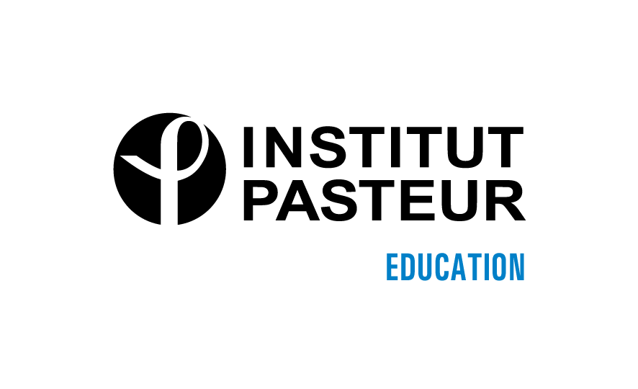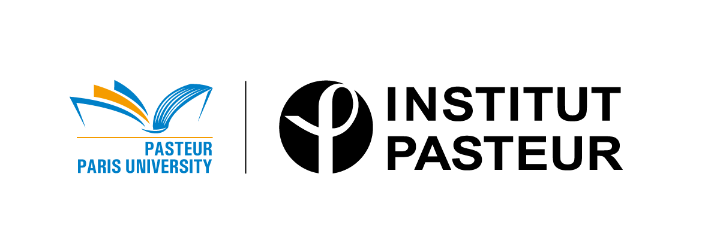

Pasteur Paris University (PPU)
Research & Technological Doctoral Program

APPLICATION FORM (1 unique pdf document to send to the project co-directors)

Project Acronym :
Title :

Candidate
First name :
Last name :

Academic training
University(ies) leading to B.A or B.S degree or equivalent ?
University(ies) leading to Master's degree ?
In case of no formal Master's degree, other diplomas or qualifications ?
Additional research experience
Laboratory experience other than the Master's research :

General Information
Current activities :
Work experience :
Languages :

Awards, Publications, Presentations at Conferences
Awards :
Publications :
Presentations at conferences:

Title and summary of your previous research project
Describe your previous research (maximum 500 characters including spaces):

Personal information
How did you learn about this program? :
What would be a good way to promote this program at your university ? :
What are your non- academic interests? :

CV in the Europass format (Annex 1)
Motivation letter by the student (Annex 2)
List your main subjects of scientific interest; give the reasons for the choice of the project; explain how your background fits the project; describe what are your career plans immediately after the PhD and for the future.

Two Recommendation letters
Each of the 2 referees has to send directly to each of the project co-directors a 1-page maximum recommendation letter.

Administrative documents (Annex 3)
Transcripts of the student's grades of Master's and B.A or B.S.
Copy of last diploma :
Copy of student passport or European ID card :

